Chapter 5-[Sets](https://mfleck.cs.illinois.edu/building-blocks/version-1.3/sets.pdf)

Thursday, December 29, 2022

12:39 AM

***Sets:***

An *unordered* collection of objects. (unordered means as long as the same values are present, it is considered the same set)

Ways to define a set:

1. describe its contents in mathematical English, e.g. “the integers between 3 and 7, inclusive.”
2. list all its members, e.g. {3,4,5,6,7}
3. use so-called set builder notation



(note that the **|** can be swapped with **:** when **|** needs to be used in the right side of the notation)

In **Tuples** duplicates and ordering matters, but not in sets.

*Note that* ***(****1,2,2,3****)*** *is a tuple, and* ***{****1,2,2,3****}*** *is a set.*

A tuple cannot contain less than 2 objects, and a set can be empty (with the symbol Ø)

***Cardinality:***

A finite set X's Cardinality is |X|, which is the number of **different** objects in X.



A is a **Subset** of B is every element of A is also in B.



The 2 sets might be the same.



A is the **Proper Subset** of B, they may NOT be the same.



*Vacuously True:*

*Weird statements that are true because the condition is always false.*

***Operations:***

***Intersection of two sets:***



gives a set containing all objects that are in both A and B.

If the resulting set of the intersection operation is am empty set, then the 2 sets are said to be **Disjoint**. (no element in common)

***Union of two sets:***



gives a set containing objects that are in either A or B.

(Adds two sets together)

***Difference of two sets:***



gives a set containing objects that are in A but not in B.

***Complement of two sets:***



gives a set containing all objects that are NOT in A.

Note that a *Universal Set* needs to be defined when using the complement operation.



*(Universal Set can be whatever set we define it to be)*

***Cartesian product of two sets:***



gives a set containing ordered pairs (x, y) where x is in A and y is in B.

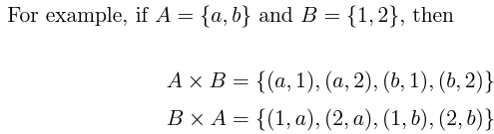



*(D*istributively *Multiply)*



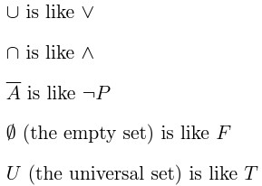

***Calculating the Number of Elements in the Union of Sets:***



(sum the size of each set and subtract all overlapping elements)

*And then there's this monstrosity:*

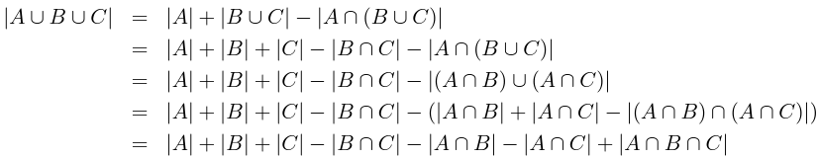

*(distributive property in step 3 and removed the pointless parenthesis and the extra A in the last step)*

***The Product Rule:***

if you have p choices for one part of a task, then q choices for a second part, and your options for the second part don’t depend on what you chose for the first part, then you have pq options for the whole task.

*(so if there are p elements in A, q elements in B, then the size of (A X B) is p*q)*

We can often combine the Inclusion-Exclusion Principle and the Product Rule to find the size of complex sets.

***General Proof Form to Show A is a Subset of B:***

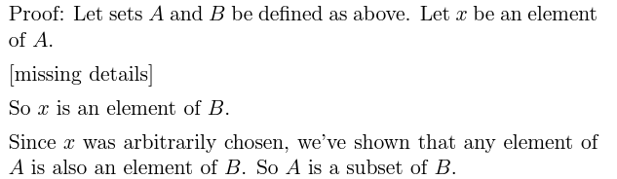

*(and remember that you can start from the top, but also work backwards from the bottom at some point after starting from the top to help fill out most of the missing details using given/obvious information)*

A general tip of proofs is that the proof should use all the information in the hypothesis of the claim. If that’s not the case, either the proof has a bug, or the claim could be revised to make it more "*interesting*."

Example:



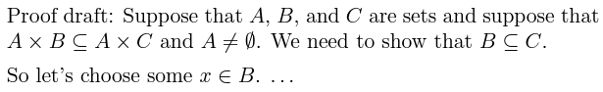

(We need to relate A X B and A X C using individual elements)

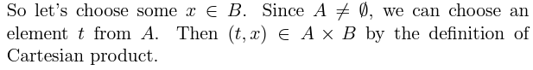

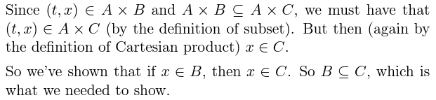

Another Example:

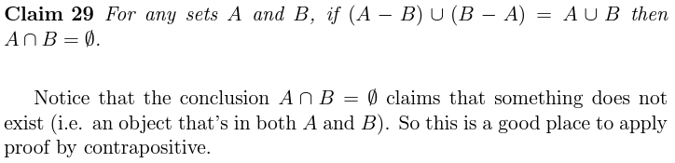

*(also the conclusion is a basic statement, while the given is complex, and often it is easier to use something basic to proof something complex, so we take the contrapositive)*

